

**PROJECT OF**

**CLOUD APPLICATION DEVELOPMENT**

**Under the guidance of**

**Mr. Saurabh Shanu**

**By:**

**Sachin Kumar**

**500086689**

**R2142201701**

**B3 Non-HONS.**

**TITLE :**

**Online Banking Web Application.**

**Overview:-**

Internet Banking is all about knowing our customer need and provide them with the right service at the right time through right channel 24*7 day a week.

Being “electronic”, it not only provides its customers with faster and better facilities, it even reduces the manual overhead of accounts maintenance.

**Purpose:-**

The Online Banking suite provides a global accounting foundation that provides the all private banks with electronic banking facilities. It allows client of private banks to carry out their day to day banking transactions.

The Online Banking project is widely applicable with private banks. It can even be used in industries for their personal transactions.

* Withdrawal of amount by the client.
* Deposition of amount by the client.
* Faster balance enquiry.

**Function:-**

1. Customer must have a valid user ID and password to login to the system.

2. After the valid user logs in, the system shows the present balance in that particular account number.

3. Customer can perform transactions like deposit and withdrawal from his account.

4. Proper help to be provided as and when requested by the customer.

**LITERATURE REVIEW**

[1] The evaluated literature concentrates on four key areas to describe Internet Banking and its features. The dissemination of innovation, the paradigm for technology acceptance, and the element of trust are discussed in the sections that follow. Parts of the literature investigate the segmentation component, but more attention is needed.

* **Diffusion of Innovation:-**This model views Internet Banking adoption as a social construct and it moves through the population over time.
* Relative advantage
* Compatibility
* **Observability:-** Observability indicates to which extent the use of the innovation is visible to other members of a social system.

[2] The developed system is an innovation in the area of online banking. In the existing system the no. of staff required for completing the work is more, while the new system requires lesser staffs generally.

The data entry process requires the data on the paper, which is then feed into the application by the operator while doing so; the data entry operator has to look into the paper again &again and thus the chances of in accuracies in the typed contents increases. Also the process includes higher transportation cost, increased handling cost, more time delays, low accuracy, more usage of resources like registers, books, papers, etc.

**Why Usage the online banking:-**

Almost 60% of today’s information is still paper based.

* 30% of all office time is spent finding documents.
* The average time to manage a single document is 12 minutes,

9 minutes to re-file and 3 minutes to process.

Hence the requirement is to develop a system that minimizes all these overheads included while giving the maximum output for the organization.

The basis for the project is to develop a fully automated banking system that includes depositing of amount, withdrawal of amount and exporting the outcome back to the client while considering all the tools and facilities than a client may need for efficient and effective output.

**Benefits of the system**

* Quick, authenticated access to accounts via the desktop.
* Easily scalable to grow with changing system requirement.
* Enterprise wide access to information.
* Improved information security, restricting unauthorized access.
* Minimize Storage Space.

In manual system, much storage space for data files is required so to overcome this problem, on automated well managed database is developed for saving storage space. This s/w saves space and stores information efficiently. It ends the burden of having large manual filing storage system.

**Requirement of cloud**

Many banking organizations have already moved to the cloud, allowing them to scale more quickly and achieve levels of agility that would not be possible with traditional on-premises IT infrastructures. The benefits of cloud computing for banks include more effective operations, reduced IT costs, and extremely secure data.

**Quick response to volatile conditions:** the ability to respond quickly to volatile market conditions improves market and credit risk management capabilities. Whether for running calculations or maintaining operational processes, the advantages of cloud computing provide a bank with the ability to react to market changes faster and always be one step ahead of competitors.

**Improved development agility:** cloud computing for banks helps to alleviate the high pressure that developers experience in the agile environment and to increase the transparency of their code, which generates value for the product owner. The right cloud banking solution promotes innovations and increased efficiencies and ensures a faster time to delivery.

**Accurate and reliable**[**predictive modeling**](https://www.compatibl.com/model-validation-consultancy/): this enables banks to predict outcomes more accurately based on the larger volumes of statistical data that cloud-native computing banking technology can process.

**Maximized cybersecurity:** the top cloud banking solutions are heavily protected from DDoS attacks, have security protocols in place to protect you from data breaches, and maintain enhanced infrastructures for compliance, with 24/7 support to ensure the bank is always online.

**New revenue opportunities:** the cloud is a powerful tool that enables banks to combine, integrate, and analyze all their data simultaneously, regardless of its source, type, size, or format.

**Flow Charts:-**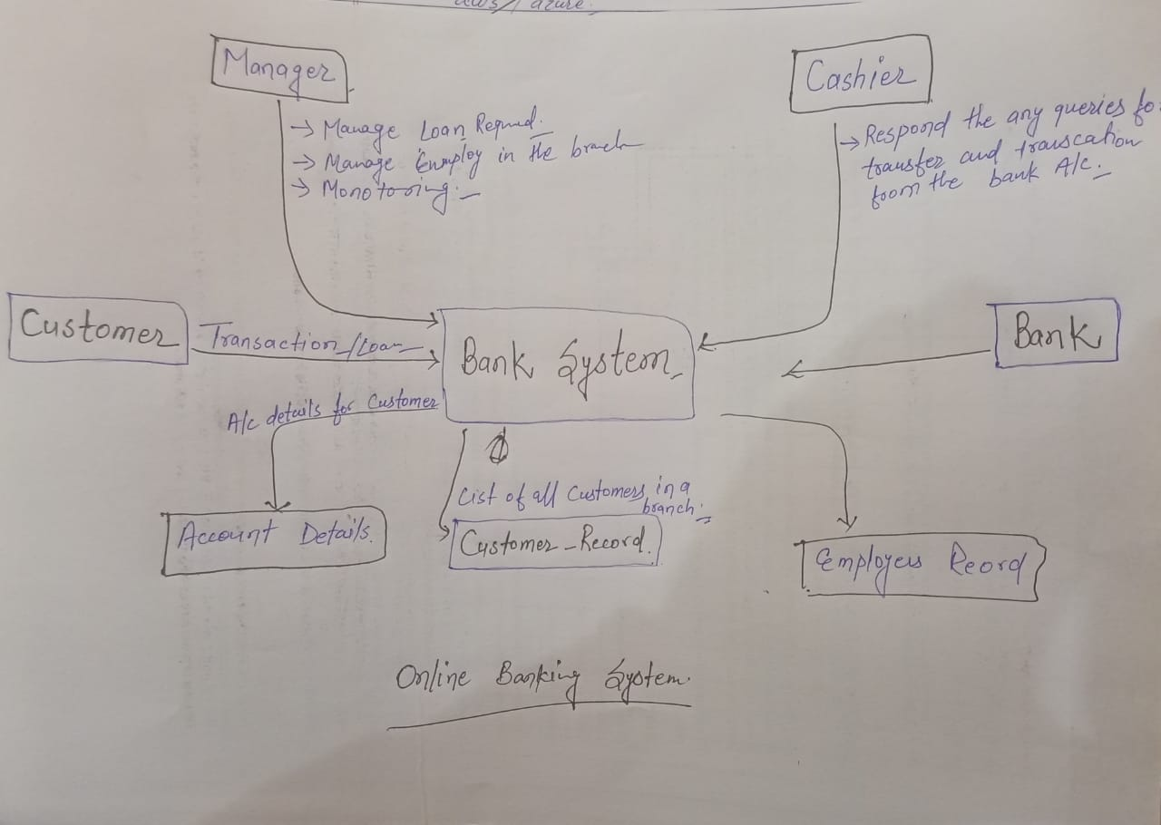

**Technologies Stacks**

**IDE:**

My Eclipse.

**Front End:**

JSP, JDBC, JavaScript

**Programming Language:**

JAVA

**Back End:**

Oracle database.